Vector Basics

[Link_1](http://zonalandeducation.com/mstm/physics/mechanics/forces/forceComponents/forceComponents.html)

[Link_2](https://www.mathsisfun.com/algebra/vectors-dot-product.html)

a)

The Vector is called a "stedvector" or position vector. Position vectors have their starting point at position origin O(0,0) in a coordinate system.

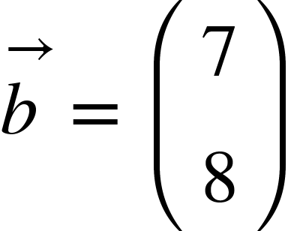

b) Two points, A and B, in a coordinate system are given by

A = (4, 3), B = (7, 8).

The vector a goes from A to B. What is a ?

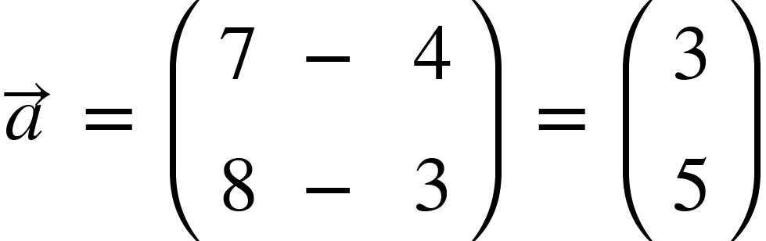

c)

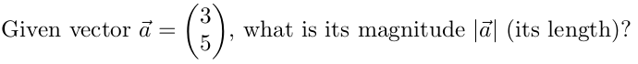

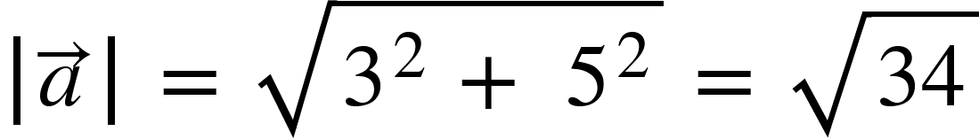

d)



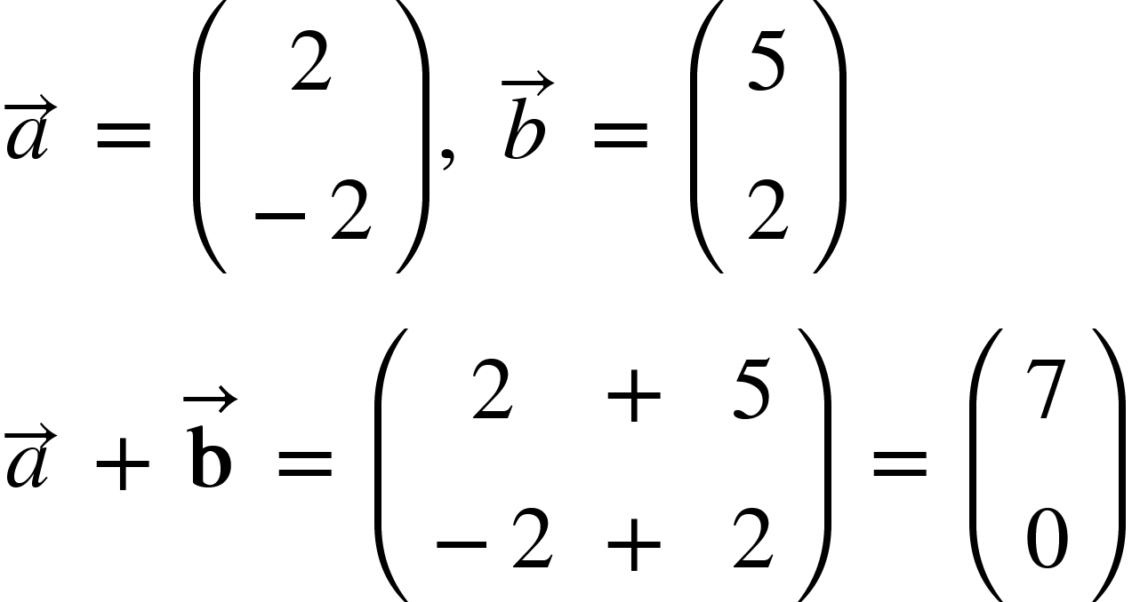

e)

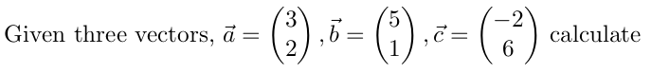

<math xmlns="http://www.w3.org/1998/Math/MathML"><mover accent="true"><mi>a</mi><mo>&#x2192;</mo></mover><mo>=</mo><mfenced><mtable><mtr><mtd><mn>3</mn></mtd></mtr><mtr><mtd><mn>2</mn></mtd></mtr></mtable></mfenced><mo>,</mo><mo>&#xA0;</mo><mover accent="true"><mi>b</mi><mo>&#x2192;</mo></mover><mo>=</mo><mfenced><mtable><mtr><mtd><mn>5</mn></mtd></mtr><mtr><mtd><mn>1</mn></mtd></mtr></mtable></mfenced><mo>,</mo><mo>&#xA0;</mo><mover accent="true"><mi>c</mi><mo>&#x2192;</mo></mover><mo>=</mo><mfenced><mtable><mtr><mtd><mo>-</mo><mn>2</mn></mtd></mtr><mtr><mtd><mn>6</mn></mtd></mtr></mtable></mfenced><mspace linebreak="newline"/><mspace linebreak="newline"/><mover><mi>a</mi><mo>&#x2192;</mo></mover><mo>&#xA0;</mo><mo>+</mo><mo>&#xA0;</mo><mover><mi>b</mi><mo>&#x2192;</mo></mover><mo>&#xA0;</mo><mo>=</mo><mo>&#xA0;</mo><mfenced><mtable><mtr><mtd><mn>3</mn></mtd><mtd><mo>+</mo></mtd><mtd><mn>5</mn></mtd></mtr><mtr><mtd><mn>2</mn></mtd><mtd><mo>+</mo></mtd><mtd><mn>1</mn></mtd></mtr></mtable></mfenced><mo>&#xA0;</mo><mo>=</mo><mo>&#xA0;</mo><mfenced><mtable><mtr><mtd><mn>8</mn></mtd></mtr><mtr><mtd><mn>3</mn></mtd></mtr></mtable></mfenced><mspace linebreak="newline"/><mspace linebreak="newline"/><mover><mi>b</mi><mo>&#x2192;</mo></mover><mo>&#xA0;</mo><mo>+</mo><mover><mi>c</mi><mo>&#x2192;</mo></mover><mo>&#xA0;</mo><mo>=</mo><mo>&#xA0;</mo><mfenced><mtable><mtr><mtd><mn>5</mn></mtd><mtd><mo>+</mo></mtd><mtd><mo>-</mo><mn>2</mn></mtd></mtr><mtr><mtd><mn>1</mn></mtd><mtd><mo>+</mo></mtd><mtd><mn>6</mn></mtd></mtr></mtable></mfenced><mo>&#xA0;</mo><mo>=</mo><mo>&#xA0;</mo><mfenced><mtable><mtr><mtd><mn>3</mn></mtd></mtr><mtr><mtd><mn>7</mn></mtd></mtr></mtable></mfenced><mspace linebreak="newline"/><mspace linebreak="newline"/><mfenced><mrow><mover><mi>a</mi><mo>&#x2192;</mo></mover><mo>&#xA0;</mo><mo>+</mo><mo>&#xA0;</mo><mover><mi>b</mi><mo>&#x2192;</mo></mover></mrow></mfenced><mo>&#xA0;</mo><mo>+</mo><mo>&#xA0;</mo><mover><mi>c</mi><mo>&#x2192;</mo></mover><mo>&#xA0;</mo><mo>=</mo><mo>&#xA0;</mo><mfenced><mfenced><mtable><mtr><mtd><mn>3</mn></mtd><mtd><mo>+</mo></mtd><mtd><mn>5</mn></mtd></mtr><mtr><mtd><mn>2</mn></mtd><mtd><mo>+</mo></mtd><mtd><mn>1</mn></mtd></mtr></mtable></mfenced></mfenced><mo>&#xA0;</mo><mo>+</mo><mo>&#xA0;</mo><mfenced><mtable><mtr><mtd><mo>-</mo><mn>2</mn></mtd></mtr><mtr><mtd><mn>6</mn></mtd></mtr></mtable></mfenced><mo>&#xA0;</mo><mo>=</mo><mo>&#xA0;</mo><mfenced><mtable><mtr><mtd><mn>8</mn></mtd><mtd><mo>+</mo></mtd><mtd><mo>-</mo><mn>2</mn></mtd></mtr><mtr><mtd><mn>3</mn></mtd><mtd><mo>+</mo></mtd><mtd><mn>6</mn></mtd></mtr></mtable></mfenced><mo>&#xA0;</mo><mo>=</mo><mo>&#xA0;</mo><mfenced><mtable><mtr><mtd><mn>6</mn></mtd></mtr><mtr><mtd><mn>9</mn></mtd></mtr></mtable></mfenced><mspace linebreak="newline"/><mspace linebreak="newline"/><mover><mi>a</mi><mo>&#x2192;</mo></mover><mo>&#xA0;</mo><mo>+</mo><mo>&#xA0;</mo><mfenced><mrow><mover><mi>b</mi><mo>&#x2192;</mo></mover><mo>&#xA0;</mo><mo>+</mo><mo>&#xA0;</mo><mover><mi>c</mi><mo>&#x2192;</mo></mover></mrow></mfenced><mo>&#xA0;</mo><mo>=</mo><mo>&#xA0;</mo><mfenced><mtable><mtr><mtd><mn>3</mn></mtd></mtr><mtr><mtd><mn>2</mn></mtd></mtr></mtable></mfenced><mo>&#xA0;</mo><mo>+</mo><mo>&#xA0;</mo><mfenced><mfenced><mtable><mtr><mtd><mn>5</mn></mtd><mtd><mo>+</mo></mtd><mtd><mo>-</mo><mn>2</mn></mtd></mtr><mtr><mtd><mn>1</mn></mtd><mtd><mo>+</mo></mtd><mtd><mn>6</mn></mtd></mtr></mtable></mfenced></mfenced><mo>&#xA0;</mo><mo>=</mo><mo>&#xA0;</mo><mfenced><mtable><mtr><mtd><mn>3</mn></mtd><mtd><mo>+</mo></mtd><mtd><mn>3</mn></mtd></mtr><mtr><mtd><mn>2</mn></mtd><mtd><mo>+</mo></mtd><mtd><mn>7</mn></mtd></mtr></mtable></mfenced><mo>&#xA0;</mo><mo>=</mo><mo>&#xA0;</mo><mfenced><mtable><mtr><mtd><mn>6</mn></mtd></mtr><mtr><mtd><mn>9</mn></mtd></mtr></mtable></mfenced><mo>&#xA0;</mo><mspace linebreak="newline"/><mspace linebreak="newline"/><mspace linebreak="newline"/><mspace linebreak="newline"/><mspace linebreak="newline"/><mspace linebreak="newline"/><mspace linebreak="newline"/></math>

Vector Decomposition

f) In Figure 3, what is the x-component of the force applied?

What is the y-component?

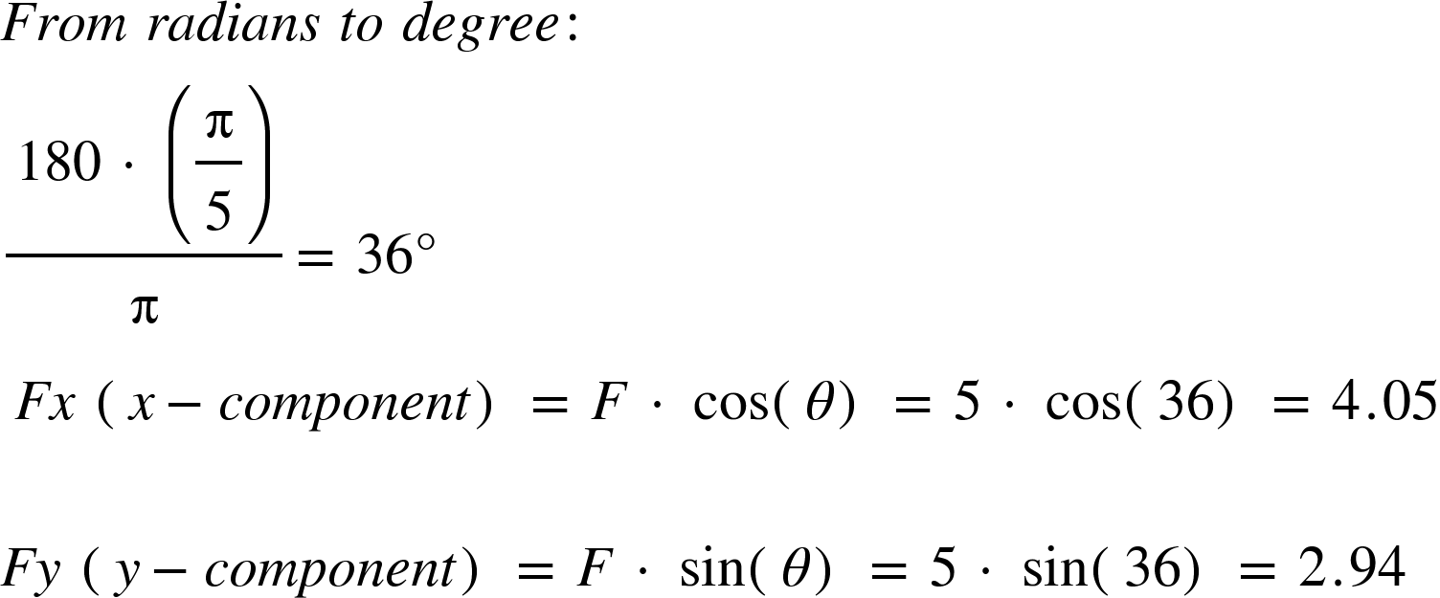

g)



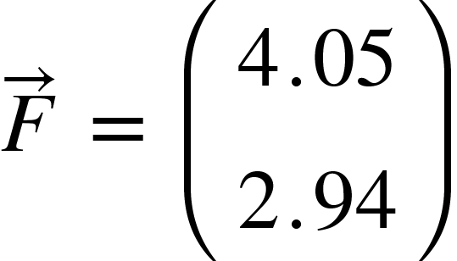

h)

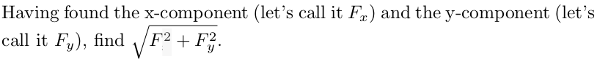

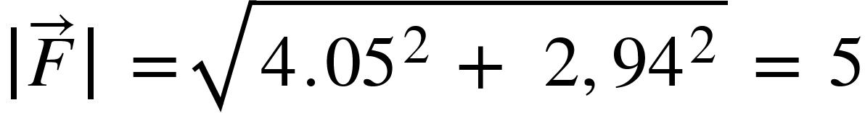

Multiplication of a Vector with a Scalar

i)

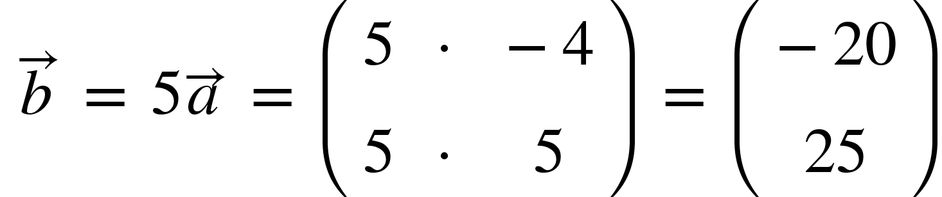

j)

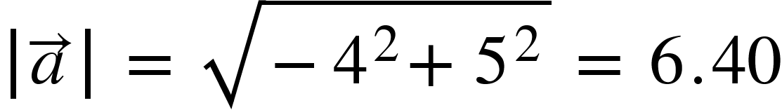

k)

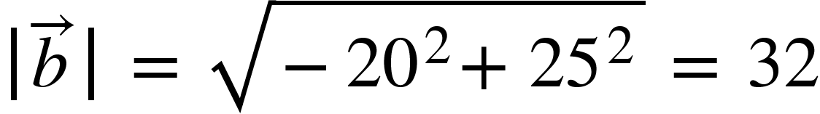

l)

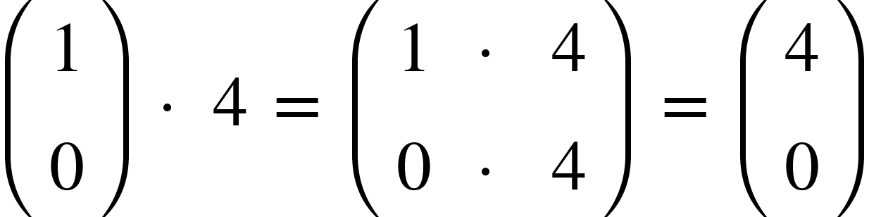

m)

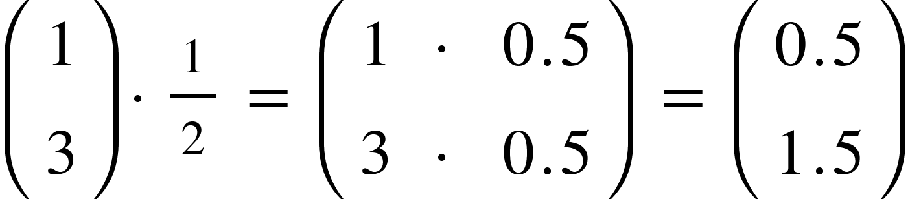

Unit Vectors

n) Given any vector, how can you find it’s unit vector?

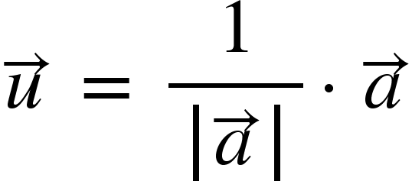

o)

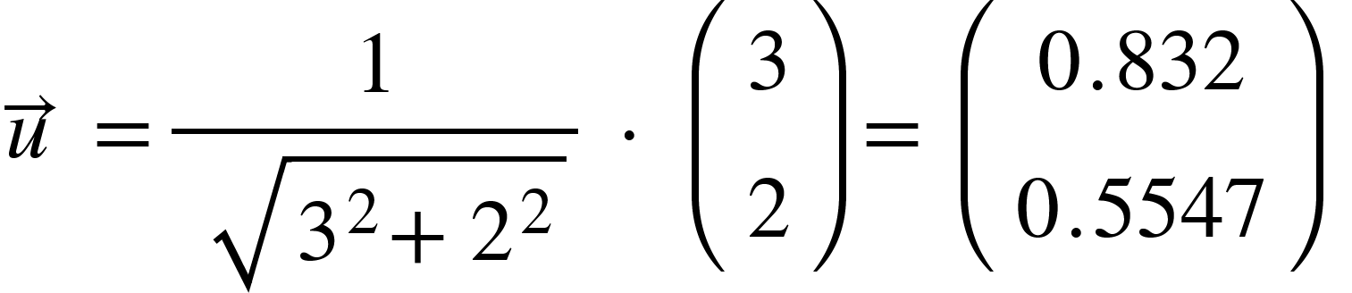

p)

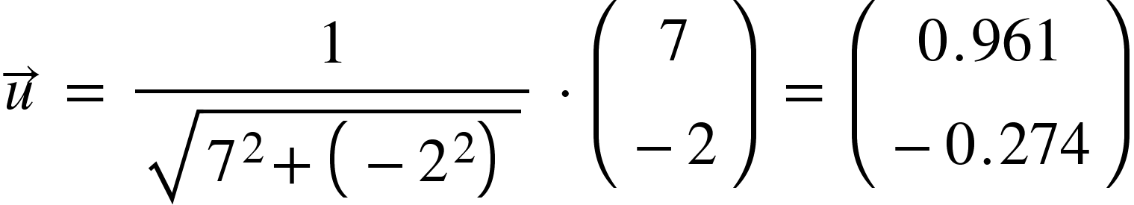

Dot Product / Scalar Product

q and r)

<math xmlns="http://www.w3.org/1998/Math/MathML"><mover><mi>a</mi><mo>&#x2192;</mo></mover><mo>&#xA0;</mo><mo>=</mo><mo>&#xA0;</mo><mfenced><mtable><mtr><mtd><mn>2</mn></mtd></mtr><mtr><mtd><mn>3</mn></mtd></mtr></mtable></mfenced><mo>&#xA0;</mo><mi>a</mi><mi>n</mi><mi>d</mi><mo>&#xA0;</mo><mover><mi>b</mi><mo>&#x2192;</mo></mover><mo>&#xA0;</mo><mo>=</mo><mo>&#xA0;</mo><mfenced><mtable><mtr><mtd><mn>4</mn></mtd></mtr><mtr><mtd><mn>6</mn></mtd></mtr></mtable></mfenced><mo>&#xA0;</mo><mspace linebreak="newline"/><mspace linebreak="newline"/><mover><mi>a</mi><mo>&#x2192;</mo></mover><mo>&#xB7;</mo><mover><mi>b</mi><mo>&#x2192;</mo></mover><mo>&#xA0;</mo><mo>=</mo><mo>&#xA0;</mo><msqrt><msup><mn>2</mn><mn>2</mn></msup><mo>+</mo><msup><mn>3</mn><mn>2</mn></msup></msqrt><mo>&#xA0;</mo><mo>&#xB7;</mo><mo>&#xA0;</mo><msqrt><msup><mn>4</mn><mn>2</mn></msup><mo>+</mo><msup><mn>6</mn><mn>2</mn></msup><mo>&#xA0;</mo></msqrt><mo>&#xA0;</mo><mo>&#xB7;</mo><mo>&#xA0;</mo><mi>cos</mi><mfenced><mn>1</mn></mfenced><mo>&#xA0;</mo><mo>=</mo><mo>&#xA0;</mo><mn>26</mn><mo>&#xA0;</mo><mo>&#x2261;</mo><mo>&#xA0;</mo><mn>2</mn><mo>&#xB7;</mo><mn>4</mn><mo>+</mo><mn>3</mn><mo>&#xB7;</mo><mn>6</mn><mspace linebreak="newline"/><mspace linebreak="newline"/><mover><mi>a</mi><mo>&#x2192;</mo></mover><mo>&#xA0;</mo><mo>=</mo><mo>&#xA0;</mo><mfenced><mtable><mtr><mtd><mn>2</mn></mtd></mtr><mtr><mtd><mn>3</mn></mtd></mtr></mtable></mfenced><mo>&#xA0;</mo><mi>a</mi><mi>n</mi><mi>d</mi><mo>&#xA0;</mo><mover><mi>b</mi><mo>&#x2192;</mo></mover><mo>&#xA0;</mo><mo>=</mo><mo>&#xA0;</mo><mfenced><mtable><mtr><mtd><mo>-</mo><mn>3</mn></mtd></mtr><mtr><mtd><mn>2</mn></mtd></mtr></mtable></mfenced><mo>&#xA0;</mo><mspace linebreak="newline"/><mover><mi>a</mi><mo>&#x2192;</mo></mover><mo>&#xB7;</mo><mover><mi>b</mi><mo>&#x2192;</mo></mover><mo>&#xA0;</mo><mo>=</mo><mo>&#xA0;</mo><msqrt><msup><mn>2</mn><mn>2</mn></msup><mo>+</mo><msup><mn>3</mn><mn>2</mn></msup></msqrt><mo>&#xA0;</mo><mo>&#xB7;</mo><mo>&#xA0;</mo><msqrt><mo>-</mo><msup><mn>3</mn><mn>2</mn></msup><mo>+</mo><msup><mn>2</mn><mn>2</mn></msup><mo>&#xA0;</mo></msqrt><mo>&#xA0;</mo><mo>&#xB7;</mo><mo>&#xA0;</mo><mi>cos</mi><mfenced><mn>90</mn></mfenced><mo>&#xA0;</mo><mo>=</mo><mo>&#xA0;</mo><mn>0</mn><mo>&#xA0;</mo><mo>&#x2261;</mo><mo>&#xA0;</mo><mn>2</mn><mo>&#xB7;</mo><mo>-</mo><mn>3</mn><mo>+</mo><mn>3</mn><mo>&#xB7;</mo><mn>2</mn><mspace linebreak="newline"/></math>

import numpy as np

*# Using Python and numpy, implement a mag(vec) function to return the*

*# magnitude (length) of a 2-dimensional vector (as a numpy array).*

*# s)*

def mag(vec):

return round(np.linalg.norm(vec), 2)

print(mag([2, 2]))

*# Likewise, implement a unit(vec) function to return the unit vector of a*

*# 2-dimensional vector (as a numpy array).*

*# t)*

def unit(vec):

return np.array([1 / mag(vec) * vec[0], 1 / mag(vec) * vec[1]])

print(unit([3, 2]))

*# Rotating a 2D vector 90 degrees counter clockwise is done by swapping x*

*# and y, and negating the new x. Implement rot90(vec). It must return a*

*# new numpy array, that is a 90 degree rotation of the vec input.*

*# u)*

def rot90(vec):

num = vec[0]

vec[0] = -vec[1]

vec[1] = num

return np.array(vec)

print(rot90([3, 2]))

*# v)*

def scale_vec(num, vec):

return np.array([num * vec[0], num * vec[1]])

print(scale_vec(2, [3, 2]))

*# W)*

def add(vec1, vec2):

return np.array([vec1[0] + vec2[0], vec1[1] + vec2[1]])

def minus(vec1, vec2):

return np.array([vec1[0] - vec2[0], vec1[1] - vec2[1]])

print(minus(add([3, 2], [8, 7]), [1, 5]))

*# X)*

*# Use help(numpy) (or online documentation) to find out how to find the*

*# dot product of two vectors. (hint: in the help prompt, you can search by*

*# pressing /, then typing text, then enter, then n or shift-n to navigate*

*# the search results!)*

a = np.array([2, 3])

b = np.array([5, 6])

print(np.dot(a, b, out=None))

*# Y*

*# Using numpy, find vector a · vector a . Compare with mag(a)*mag(a).*

dot_1 = mag(a) * mag(a)

dot_2 = round(np.dot(a, a, out=None), 2)

print(**"mag function "** + str(dot_1) + **" numpy function: "** + str(dot_2))

*# Z*

*# Using numpy, find ~a · ~b.*

print(np.dot(a, b, out=None))

*# æ*

*# Using your rot90 function, find the dot product of a and its rotation.*

*# (That is, given a ~ r = rot90(a), find ~a · a ~ r )*

print(np.dot(a, rot90(a)))